Fee Lookup

•Who was the last user to update this fee?
•How did this trade end up using this rate?
•Why did fee calculation fail?
Not all questions about a trade fee can be easily answered using an aggregate view. The Fee Lookup function drills down into a single trade fee, providing users complete trade fee details, an explanation of fee calculation, and a full audit log of trade actions to explore and resolve targeted trade issues.
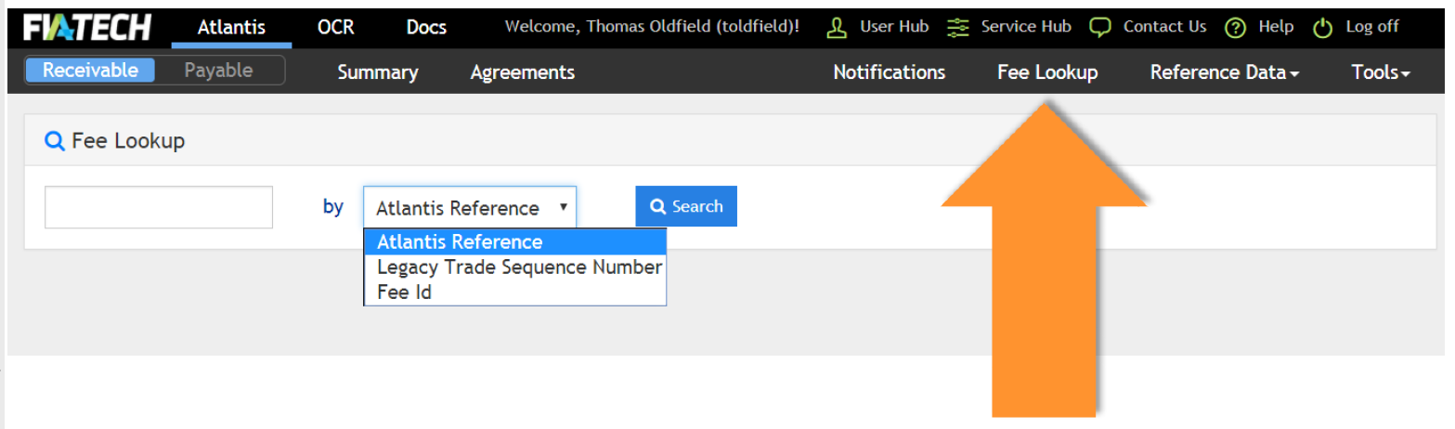

Looking Up a Fee

The “Fee Lookup” navigation button is available from any Atlantis screen. The lookup itself is a standard search bar, and allows a user to find fees based on one of three identifiers:
•Atlantis Reference ID
•Legacy Trade Sequence Number
•Fee ID

Type in the identifier, click search, and if Atlantis has a matching trade on file then the details will pop up.

Fee Lookup Features

The Fee Lookup displays a lot of information—every field Atlantis captures about a given fee is displayed here. Some highlights of the information provided in the screen:
•Rate Schedule Detail – shows the variables Atlantis used to select a rate from the Give-up Agreement
•Fee Calc Failure Reason – explanation of why a fee cannot be calculated
•Fee Actions Log – records every action taken by the Executing Broker and the Clearing Broker, complete with user ID, comments, and date

Fee Lookup in Action

Let’s put these pieces together in an example.
A Clearing Broker sees a trade pending for approval, but the trade date shows that it is 6 months old. Why is this trade only appearing now?
By typing the Atlantis Reference number into Fee Lookup, the Clearing Broker can check the Fee Actions log to find more information on the trade.
The Fee Actions Log returns these rows:
•EB -Affirm – January
•CB -Reject – February
•EB -Hold – February
•EB -Amend – June
•EB -Affirm – June
It indicates that the Clearing Broker rejected the rate back in February. The Executing Broker has now Amended the rate, placing the trade back in Payer Review. The Fee Lookup has helped understand this trade’s path through Atlantis toward settlement.

One Trade, Under the Microscope

The Fee Lookup functionality allows users to see the details of a single trade. Users can use this feature to review the history of a single trade, accurately follow that trade through its lifecycle on the system, and use that information to diagnose exceptions and unexpected results.

