Action Trades with Excel Upload/Downloads

Atlantis usually focuses on aggregates and group filters, but some workflow will require users to review, amend, or action at the individual trade level. These trade level actions are made possible with the “Download Detail” and “Upload Detail” tools. This article will review how to use the Upload/Download feature and explore some of the workflow options that it enables.

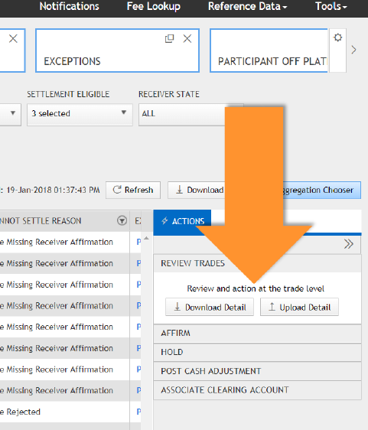

# Basic Use Case

The “Download Detail” and “Upload Detail” options are available under ACTIONS->REVIEW TRADES on the Atlantis summary screens. In a standard use case, the user will:

* Identify the data to be actioned. Using the Atlantis Filters and Aggregation Choosers, pull a subset of data onto the summary screen. Using the checkboxes on the left hand side, identify the groups of trades to action.
* Rather than updating the trades from the Atlantis UI, **choose the “Download Detail” action** to download an Excel file containing all of the trades in that aggregation.
* The system-generated Excel file will be available for download from the Notifications screen. Depending on the number of trades included, this may take a few minutes to fully generate.
* Click the **Notifications** link to download the Excel file. Open the file and apply changes on a trade-by-trade basis.
* Once satisfied with the changes, save the file and **re-upload it into Atlantis.** The requested actions will be updated in the system and any necessary fee recalculations will automatically occur. Depending on the size of the file, this may take a minute to complete. Any errors will be displayed directly to the Notifications screen.

The actions available through the Download/Upload workflow go beyond those available through the UI. They include:

* Approvals
* Rejections
* Affirmations
* Holds
* Amendments (exclusive to Download/Upload)

The following fields can be amended:

* Receiver Participant
* Adjusted Fee Amount
* Fee Currency
* Transaction Type
* Spread Type
* Execution Method
* Executing Account
* Give Up Reference

The “Comment” field next to each action allows counterparties know what has been actioned and why.

# Speed Updates Using Atlantis Reference ID

Not every field on the spreadsheet needs to be filled out- having Atlantis Reference ID, Action, Comment, and (if amending) the field that needs to change is enough. This flexibility opens up useful workflow options:

* Use a list of **Atlantis References** from a downstream system, copy and paste them into a spreadsheet, then upload to action.
* Pre-fill an excel sheet with a list of Atlantis References IDs to provide counterparties a quick, convenient way to action trades.

# Preparing the Atlantis Reference ID Upload

When uploading a spreadsheet, take care to confirm that it contains only the data that will be actioned. Particularly when uploading data from a downstream system, it is good practice to completely delete existing data so that the spreadsheet is blank and does not include any unwanted values. Any trades accidentally left behind could cause problem uploads, or even create bad data.

**Payables and Receivables spreadsheets are formatted differently and not interchangeable**. It is important to check that the correct spreadsheet is used for the upload.

# Upload in Action: Execution Methods

Let’s put together these tools in a quick example.

A firm’s downstream reconciliation system has found an exception - they have **100 trades in Atlantis rating incorrectly**, and they suspect that it is due to an incorrect execution method.

**Some of these trades are voice execution, some are electronic, so how can they all be updated?**



**The Upload/Download function makes this update possible.** Download Atlantis Reference IDs and Execution Methods straight from the downstream system or books, and paste them into the appropriate columns on a blank spreadsheet.

Mark each row with the “Amend” action, and comment “Wrong Execution Method”. Save the spreadsheet and upload it back into Atlantis. The trades will recalculate their rates using the new execution method.

# Quick, Trade-Level Updates

The Upload/Download functionality allows for quick adjustments at the trade level. It is a powerful tool for updating trades, communicating with counterparties, and settling brokerage faster.